## Problem

The *defaultdict* tool is a container in the collections class of Python. It's similar to the usual dictionary (*dict*) container, but the only difference is that a defaultdict will have a *default* value if that key has not been set yet. If you didn't use a defaultdict you'd have to check to see if that key exists, and if it doesn't, set it to what you want.  
**For example:**

from collections import defaultdict

d = defaultdict(list)

d['python'].append("awesome")

d['something-else'].append("not relevant")

d['python'].append("language")

for i in d.items():

print i

This prints:

('python', ['awesome', 'language'])

('something-else', ['not relevant'])

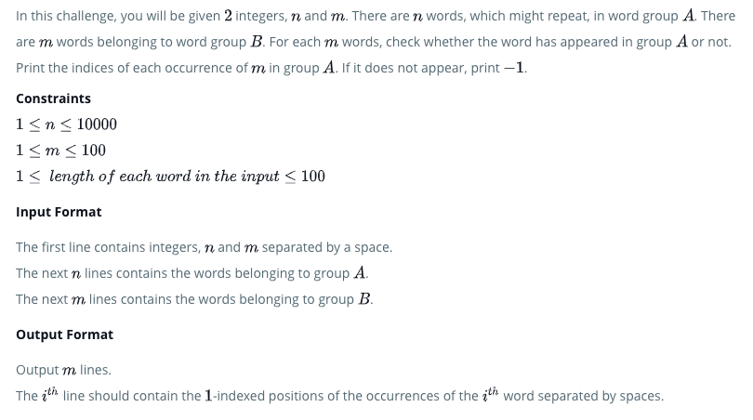

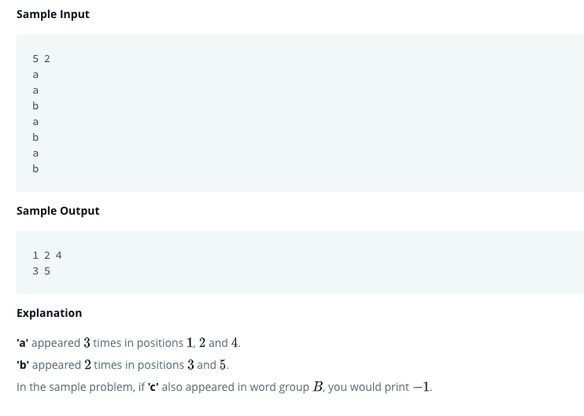

## Solution

# Enter your code here. Read input from STDIN. Print output to STDOUT

from collections import defaultdict

d = defaultdict(list)

list1=[]

n, m = map(int,input().split())

for i in range(1, n+1):

    d[input()].append(str(i))

for i in range(m):

    b = input()

    if b in d: print(' '.join(d[b]))

    else: print(-1)